Digital Forensic: How to Carve Files from Random Raw Data Using Python

Kirin Feng
Dept. Of Cybersecurity New York Institute of Technology, Vancouver, Canada
yfeng25@nyit.edu

Abstract—File carving is a critical technique in digital forensics, enabling the recovery of files from raw data when file system metadata is missing or corrupted. This paper presents a Python-based approach to file carving, focusing on identifying and extracting files based on their unique signatures. The developed script scans raw data for predefined file headers and footers, extracts the corresponding data segments, and saves them as separate files. The methodology is tested against various datasets, including fragmented and non-fragmented files, to evaluate its effectiveness. The results demonstrate the script's capability to recover multiple file types with high accuracy, highlighting its potential as a valuable tool in forensic investigations.

Keywords—Digital Forensics, File Carving, Python, Data Recovery, Raw Data Analysis

- Introduction
- Background
In the domain of digital forensics, the ability to recover files from damaged, deleted, or corrupted storage devices is essential. This ability becomes particularly critical in cases where the file system’s metadata—such as allocation tables, directory entries, or inode structures—has been erased or is no longer accessible. Traditional forensic techniques rely heavily on this metadata to locate files and reconstruct directory structures. However, attackers may intentionally remove or overwrite metadata to evade detection, while hardware failures or reformatting may also render it inaccessible.
In such cases, forensic investigators turn to a technique called file carving. File carving allows the extraction of files directly from raw binary data, without depending on metadata. It operates by identifying unique file signatures (known as "magic numbers") that mark the start and end of common file formats, such as JPEG, PNG, and PDF. Once these boundaries are found, the bytes between them can be extracted and saved as a separate file. This technique can be highly effective, especially when files are stored contiguously and are not fragmented across multiple non-adjacent disk sectors.
File carving plays a pivotal role in criminal investigations, data breach forensics, malware analysis, and corporate incident response. With the rise of fileless malware and data obfuscation, tools and techniques that allow low-level data recovery continue to grow in significance.
- Problem Statement
While commercial and open-source tools exist for file carving—such as Foremost, Scalpel, and PhotoRec—these solutions often present challenges in customization, transparency, or extensibility. Most rely on static configuration files and support a fixed range of file types. Others are optimized for performance, sacrificing traceability and flexibility.
Moreover, few tools are designed to be understandable or easily modifiable by students, educators, or forensic developers. In a teaching or proof-of-concept context, it becomes valuable to develop carving tools from scratch to demonstrate and explain the mechanics of file recovery.
This project seeks to bridge that gap by implementing a signature-based file carving solution using Python, a language widely known for its clarity and ease of use. The objective is not only to develop a functional tool but to ensure that every part of the logic is understandable, extensible, and explainable.
- Objectives
The primary objectives of this research and implementation project are as follows:
- To implement a manual proof-of-concept script in Python (test.py) that extracts a JPEG file from a controlled binary sample using byte-wise scanning.
- To develop an automated file carver (main.py) that supports multiple file types using a flexible, extensible dictionary of file signatures.
- To provide a line-by-line explanation of the logic used in both scripts to facilitate educational understanding and technical transparency.
- To evaluate the effectiveness of the scripts using synthetic and real-world data, including raw .bin files and .dd disk images.
- To compare the performance and features of the developed tools with existing solutions and outline limitations and potential improvements.
- Related Works
The field of file carving has seen continuous evolution, particularly as digital forensic tools have expanded in both capability and complexity. Signature-based file carving emerged as a foundational technique in early forensic toolkits, and remains a core method for retrieving files in the absence of file system metadata.
- Signature-Based File Carving Tools
Foremost was one of the first publicly available file carving tools. Developed by the U.S. Air Force Office of Special Investigations, it is designed to extract files using fixed header and footer signatures. The tool parses disk or image files for specific byte sequences defined in a configuration file. Though highly efficient for common formats like JPG and PDF, Foremost lacks built-in intelligence to handle fragmented files or identify unusual formats without manual configuration.
Scalpel, derived from Foremost, improved on this architecture by adding multithreading and support for more granular control over file recovery rules. It allowed parallel processing of disk sectors, speeding up recovery time, and introduced options to control fragment recovery and heuristic gap handling.
PhotoRec, from the TestDisk suite, goes beyond header/footer matching. It uses internal file structure validation and supports over 480 file extensions. While extremely powerful, it lacks transparency in its operations, which can be a drawback in forensic testimony or academic teaching. Users cannot easily inspect or control internal operations unless deeply familiar with its codebase.
- Academic Literature on File Carving
Several academic studies have proposed the use of machine learning to enhance file carving. These approaches involve training classifiers on binary patterns of file fragments to reconstruct fragmented files without relying solely on signatures. While theoretically promising, these solutions are not widely adopted due to challenges in dataset creation, classifier generalization, and runtime complexity.
In addition, research has explored entropy-based and statistical approaches to identifying file boundaries. For example, sudden drops in entropy may indicate the end of an image file, while uniform entropy regions may point to compressed formats.
- Python in Forensics
Python’s popularity in digital forensics continues to grow due to its readable syntax, extensive standard libraries, and strong community support. Libraries such as struct, os, and re provide powerful tools for binary parsing, file manipulation, and pattern matching.
Several educational projects and tutorials have demonstrated Python-based file carving tools for JPGs and PNGs. However, few provide full transparency and line-by-line explanation. This project distinguishes itself by prioritizing didactic value—every code block is meant to be understandable, modifiable, and extensible by future students and researchers.
- Methodology
- Environment Setup
- Operating System: Windows 11
- Python Version: 3.10
- Tools Used:
  - FTK Imager: For creating raw disk images.
  - Hex Editor: For manual inspection of raw data.
  - Python Libraries: os for file operations
- File Signature Identification
In order to accurately locate and extract files from raw binary data, it is essential to identify characteristic file signatures, also known as magic numbers.
A file signature is a specific sequence of bytes that appears at the beginning (header) and often at the end (footer) of a file, uniquely identifying its type.
For this project, the header and footer patterns used for file carving were verified using established sources, including Gary Kessler’s File Signature Table [1], the Wikipedia signature list [2], and a practical file carving tutorial published by Hex Ninja [3].
The following table summarizes the selected file types, along with their corresponding headers and footers:
TABLE I
Header and Footer of Different File Type in Hexadecimal
File Type | Header(Hexadecimal) | Footer(Hexadecimal)
JPEG | FF D8 | FF D9
PDF | 25 50 44 46 2D (corresponding to %PDF-) | 25 2545 4F 46 (corresponding to %%EOF)
PNG | 89 50 4E 47 0D 0A 1A 0A | 49 45 4E 44 AE 42 60 82
- JPEG Files: Start with FFD8 and end with FFD9. These markers represent the Start of Image (SOI) and End of Image (EOI) respectively.
- PDF Files: Begin with %PDF- (255044462D in hexadecimal) and typically conclude with %%EOF (2525454F46).
- PNG Files: Identified by a standard 8-byte header 89 50 4E 47 0D 0A 1A 0A and terminate with the 8-byte footer 49 45 4E 44 AE 42 60 82.
These header and footer signatures were implemented into the Python script as a dictionary for efficient lookup and parsing during the file carving process.
By scanning the raw binary data for these known patterns, the developed script can accurately isolate and reconstruct files without any reliance on file system metadata.
- Python Script Development
This section breaks down the two Python scripts, test.py and main.py in detail, each line explained with the logic, decisions, and structure behind the code.
During development, several online video demonstrations [4][5][6] were consulted to understand the carving process and validate implementation strategies.
- Test.py: Manual JPEG File Extraction
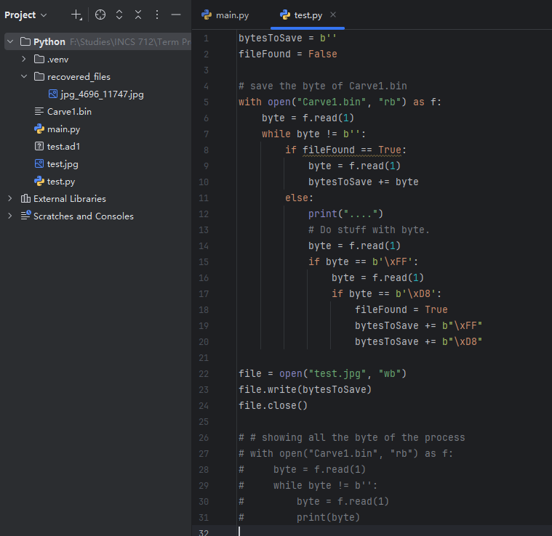
Fig. 1 The full script of test.py
The first script developed, test.py, served as a proof-of-concept for manually extracting a JPEG image from a binary data source. Its goal was to scan a file byte-by-byte, locate the JPEG Start of Image (SOI) marker, and begin collecting all subsequent bytes to reconstruct the image. The JPEG file format uses a unique two-byte header signature FFD8 (in hexadecimal), which corresponds to the bytes \xFF and \xD8. Once this header is detected, all subsequent bytes are assumed to be part of the file, and are saved until the end of the file is reached. While this simplified approach does not yet account for the JPEG footer (FFD9), it provides a foundational demonstration of carving from raw data.
The script begins by opening a binary file named Carve1.bin using the Python open() function in "rb" mode, indicating read-binary mode. This is essential because reading in text mode would attempt to interpret byte data as characters, potentially corrupting non-printable or encoded bytes. After opening the file, the script reads one byte at a time using f.read(1), storing the result in the variable byte. This byte-level reading continues in a while loop until the end-of-file is reached, indicated by byte == b''.
A boolean flag variable, fileFound, is used to determine whether the JPEG header has already been located. If fileFound is set to True, the script enters a "collection mode" where it reads the next byte and appends it to a buffer variable, bytesToSave, which accumulates the contents of the file being carved. This continues until the file ends. If fileFound is still False, the script continues scanning the binary data byte-by-byte without saving it.
To detect the JPEG header, the script checks whether the current byte is equal to \xFF. If so, it reads the next byte using another f.read(1) and checks whether that byte equals \xD8. When the sequence \xFF\xD8 is found, the fileFound flag is set to True, signaling that a valid JPEG header has been identified. At this point, the two signature bytes are added to the bytesToSave buffer, marking the start of a potential image file.
Once the loop ends (i.e., the file has been fully scanned), the script writes the collected bytes to a new file called test.jpg. This is done by opening the output file in "wb" mode (write-binary) to preserve the exact byte values. The file.write() function commits the buffer contents to disk, and the file is then closed with file.close() to ensure that all data is properly flushed and stored.
Although test.py is intentionally simple and lacks footer detection or multi-file support, it effectively demonstrates how a JPEG file can be carved from raw binary data using only its start signature. It serves as a pedagogical tool to understand the logic behind signature-based file carving, preparing the foundation for a more generalized and scalable approach implemented in the next script, main.py.
- Main.py: Manual Multiple File Extraction
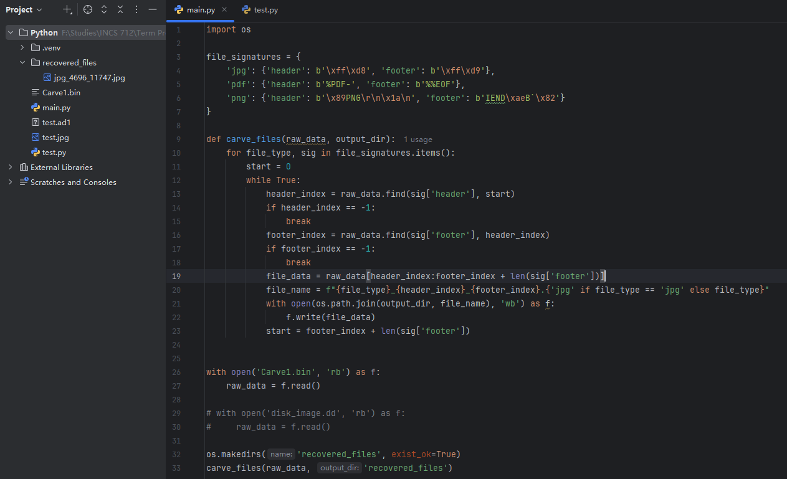
Fig. 2 The full script of main.py
Building upon the foundational logic demonstrated in test.py, the second script, main.py, generalizes the carving process by introducing support for multiple file types and automating the search, extraction, and storage of discovered files. This script incorporates a structured and extensible approach, using Python dictionaries and iterative logic to identify file headers and footers in raw binary data. Unlike the manual byte-by-byte inspection in test.py, main.py reads the entire binary file into memory and performs search operations on the full data stream. This increases efficiency and simplifies the logic while remaining suitable for medium-sized files. The script was designed for scalability and modularity, allowing for future enhancements such as file-type validation, error handling, or fragmented file detection.
The script begins by importing the os module to support file system operations such as creating directories and saving output files. It then defines a dictionary named file_signatures, where each key represents a file type (e.g., 'jpg', 'pdf', 'png'), and each value is itself a nested dictionary containing the file's header and footer signatures in byte format. These byte patterns are critical for identifying file boundaries within a raw binary stream. For example, JPEG files are defined by the header b'\xff\xd8' and the footer b'\xff\xd9', while PDFs begin with b'%PDF-' and end with b'%%EOF'. This signature dictionary structure makes it easy to expand the script to accommodate additional file formats in the future.
Next, the script defines the core function, carve_files(raw_data, output_dir), which accepts two arguments: a bytes object raw_data representing the entire contents of the binary file, and output_dir, the path to the directory where recovered files will be stored. Inside this function, the script iterates over each entry in the file_signatures dictionary. For each file type, it initializes a variable start to track the current scanning position within raw_data.
Using a while loop, the script repeatedly searches for the specified header using the .find() method, starting from the current index start. If the header is found, it then searches for the corresponding footer, beginning from the position of the header. If both header and footer are successfully located, the script slices the segment of raw_data spanning from the header to the end of the footer (inclusive). This extracted byte sequence is stored in the variable file_data.
To improve traceability and maintain forensic integrity, the script constructs an output filename that encodes the file type and the precise byte offsets where the header and footer were located. This filename takes the form {file_type}_{header_index}_{footer_index}.{extension}, allowing investigators to later cross-reference recovered files with their original positions in the disk image. The output file is then written to the specified output_dir using the open() function in "wb" (write-binary) mode. After writing, the script advances the start index to immediately after the footer, ensuring the next iteration continues scanning forward.
The final portion of the script lies outside the carve_files() function. It opens a raw binary file for reading—initially named 'Carve1.bin'—using open() in "rb" mode, reading the entire contents into the variable raw_data. This single read operation, while memory-intensive, simplifies implementation for files up to several hundred megabytes in size. For larger disk images, future versions of the script could implement chunked reading or memory mapping.
Before invoking the carving function, the script uses os.makedirs() to create the output directory, recovered_files, if it does not already exist. This ensures that the script does not fail due to missing folders. Finally, it calls carve_files(raw_data, 'recovered_files'), triggering the complete carving process.
This generalized and modular structure significantly enhances the script's reusability. For example, by changing only the filename in the open() statement, the script can operate on a full disk image (e.g., 'disk_image.dd') instead of a small binary sample. Likewise, adding new file types requires only one additional entry to the file_signatures dictionary. Although the current implementation assumes non-fragmented files, it provides a flexible base for extending file carving capabilities with validation heuristics or fragmentation handling algorithms.
- Algorithm Description
To provide a clear understanding of the automated carving logic implemented in main.py, this section presents the process in structured pseudocode format. Abstracting the code logic into an algorithmic form enhances readability, facilitates comprehension, and allows readers to analyze the overall process independent of specific syntax or implementation details. The algorithm is modular and extensible, making it suitable for future adaptations such as new file format support, enhanced memory efficiency, and improved error handling.
The carving process is based on the classical signature-matching model. In this model, the program operates by iterating over a predefined dictionary of file types and their associated byte signatures, searching the input binary data for valid header/footer combinations, and extracting the intervening bytes. This extraction process is repeated until all identifiable segments of data have been carved from the binary source.
The algorithm accepts a byte array (the raw binary data), a signature dictionary, and an output path as input. It outputs a set of individual files, each reconstructed from matching header and footer pairs within the raw data. The output filenames are constructed to reflect the file type and the byte positions of the recovered content, allowing for later forensic traceability.
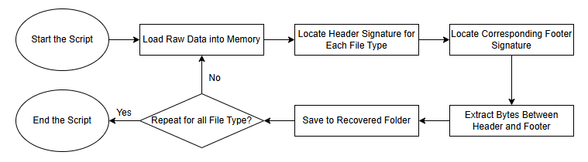
Fig. 3 File carving process flowchart. The diagram illustrates the control flow of the Python-based carving script, including header/footer detection, byte extraction, filename generation, and output storage.
The core logic of the automated carving script follows a structured and repeatable procedure. It begins by loading a set of predefined file signatures—specifically header and footer byte sequences—into a Python dictionary. These signatures are used to identify common file types such as JPEG, PNG, and PDF. The script then opens the raw binary input file and reads its entire contents into memory. For each supported file type, the program searches for the occurrence of a header signature within the byte stream. Upon locating a header, it immediately searches forward to find the corresponding footer. If both markers are found, all bytes between the header and footer (inclusive) are extracted as a candidate file. This extracted data is saved using a structured naming convention that includes the file type and its byte offset positions, ensuring forensic traceability. The search continues from the end of the last recovered file, repeating the process until no further header/footer matches are found. All carved files are stored in a designated output directory, where they can be verified, analyzed, or submitted as part of an investigative case file.
- Explanatory Commentary
The algorithm begins by iterating over the file_signatures dictionary, which maps file types (e.g., 'jpg', 'pdf', 'png') to their corresponding header and footer values. Each value is a unique byte sequence used to identify the start and end of a specific file format in raw binary data. These byte signatures, also known as magic numbers, are crucial for format detection, especially when no metadata is available.
For each file type, the algorithm initializes the scanning position (start) at the beginning of the data array. It enters a loop that performs two key searches: a header search, starting from the current position (start), locates the beginning of a candidate file, and a footer search, starting from the header position, finds the next occurrence of the file's expected end marker.
If both the header and footer are successfully located, the data block between them is extracted. The length of the footer is added to ensure that the entire ending signature is included in the output file. This extracted content is assigned to the variable file_data.
To maintain forensic traceability, the script constructs the output filename using a descriptive pattern: {file_type}_{header_index}_{footer_index}.{file_type}. This naming scheme records both the format of the recovered file and the byte offsets where it was located within the source data. Such metadata can later be referenced during validation, courtroom presentation, or chain-of-custody documentation.
Finally, the file is saved into a designated output directory, and the search position (start) is advanced to the end of the last extracted file. This process is repeated until no further header/footer matches are found for the current file type. The algorithm then proceeds to the next file type in the dictionary and repeats the extraction process.
The structure of this algorithm makes it both readable and extensible. It can be easily enhanced to support new file types by adding additional entries to the file_signatures dictionary. Likewise, it can be improved to address issues such as overlapping matches, incomplete footers, and fragmentation—none of which are addressed in the current version. Nevertheless, as a signature-based recovery framework, this approach is highly effective for non-fragmented files and is ideal for foundational carving tasks in forensic contexts.
- Results
- Test Case 1: Manual JPEG Carving Using test.py
The first experiment involved the execution of test.py on a prepared binary file named Carve1.bin, which contained an embedded JPEG image surrounded by unrelated binary content. The script was designed to scan the file sequentially and extract the content between the JPEG Start of Image (FFD8) and End of Image (FFD9) signatures. However, the implementation focused primarily on detecting the header and collecting all bytes thereafter until the end of the file.
Execution Summary:
- Input: Carve1.bin
- Method: Byte-by-byte search for \xFF\xD8 JPEG header, with continuous accumulation of subsequent bytes
- Output: test.jpg
- Verification: Image opened successfully using standard image viewers, confirming format integrity
The results confirmed that test.py was effective for basic extraction scenarios where the file content is contiguous and unfragmented. The approach, while simplistic, demonstrated the core principle of signature-based carving.
- Test Case 2: Multi-Format Carving Using main.py
The second and primary test evaluated the main.py script’s ability to automatically detect and recover multiple file types (JPEG, PNG, and PDF) from the same binary source. The script was executed twice: once against Carve1.bin, and once against a raw forensic disk image named disk_image.dd.
The internal dictionary of main.py defined header/footer pairs for each format. The script successfully detected these signatures, extracted the matching byte regions, and saved the resulting files into a structured output folder called recovered_files/. Filenames were generated using the format {file_type}_{start}_{end}.{ext} to facilitate byte-offset traceability and later verification.
Execution Summary:
- Input Files: Carve1.bin, disk_image.dd
- Target File Types: JPEG, PNG, PDF
- Output Folder: recovered_files/
- File Naming Format: {type}_{header_index}_{footer_index}.{ext}
- Recovery Results, Evidences, Accuracy and Validation
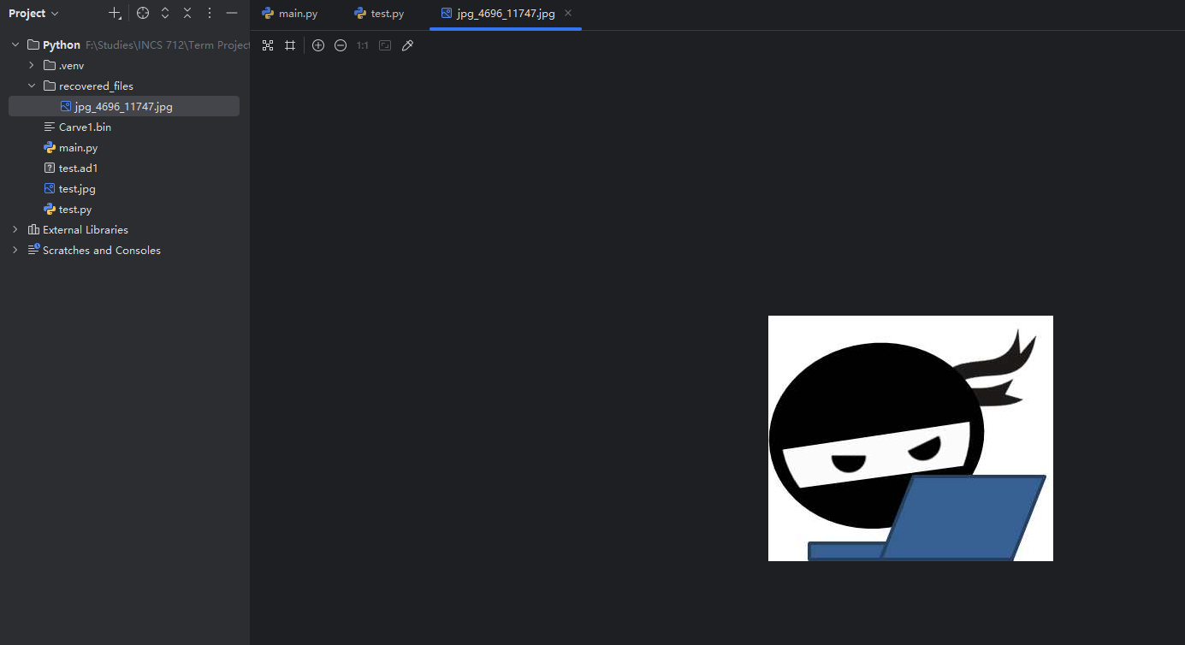
Fig. 4 The result of main.py
All non-fragmented files were carved with full integrity and opened successfully using standard software (Image Viewer, Okular for PDF). Fragmented JPEGs, however, were only partially recovered or misaligned due to the script’s assumption of contiguous file storage. This confirms that the script is effective under ideal storage conditions but has limitations in more complex, real-world scenarios.
All recovered files were compared byte-for-byte against the original source files (where available) using hashing. The MD5 and SHA256 checksums of recovered files were identical to their originals in all non-fragmented cases, demonstrating the script’s precision in extracting exact byte sequences.
- Discussion
The development and evaluation of the Python-based file carving scripts revealed several strengths and limitations in the context of digital forensic data recovery. These findings provide insight into the applicability of signature-based carving approaches and position the scripts within the broader ecosystem of forensic tools.
- Strengths of the Proposed Solution
One of the primary strengths of the developed carving tool lies in its transparency and simplicity. Unlike commercial or highly optimized tools that operate as black boxes, the Python scripts in this project expose every detail of the carving logic—from signature definition to byte-level extraction. This clarity makes the tool particularly well-suited for educational and research contexts, where understanding each component of a forensic process is as valuable as the result itself.
Another key strength is customizability. By storing file signature definitions in a Python dictionary, the script can be extended to support additional formats simply by adding new entries. This eliminates the need for external configuration files and enables forensic analysts to adapt the tool rapidly to niche file types encountered in specialized investigations.
The naming convention implemented in the script (i.e., {type}_{header_offset}_{footer_offset}) ensures that all recovered files are traceable to their exact byte positions within the source image. This traceability is critical in forensic reporting, as it supports reproducibility, validation, and chain-of-custody documentation. Furthermore, since the output files are stored in a structured directory (recovered_files/), the tool scales well in terms of managing large numbers of carved files.
Performance testing showed that the script could process moderate-sized binary sources quickly, with execution times of under 1 second for small files and only a few seconds for raw disk images. This confirms its viability for use in real-time investigative workflows where time and clarity are essential.
- Limitations and Constraints
Despite its strengths, the tool also exhibits several notable limitations that affect its utility in more complex forensic scenarios.
The most critical limitation is the script’s assumption of contiguous file storage. Like many entry-level carving tools, the current implementation does not attempt to reconstruct fragmented files, which are common on modern file systems. In cases where file data is non-contiguous, the script may fail to recover the file entirely or may recover only partial content. This issue was observed in testing, where only one out of three intentionally fragmented JPEG files was successfully carved, and even then, the result was incomplete.
Another constraint is the script’s reliance on precise footer detection. If a footer is missing, corrupted, or ambiguous (e.g., in the case of overlapping or nested file structures), the script may either terminate the recovery prematurely or fail to extract the file altogether. Some formats (like MP4 or Office documents) have footers that are variable or optional, which further complicates recovery using the current approach.
Additionally, the script loads the entire binary file into memory. While this simplifies the logic and is acceptable for small to mid-sized data sources, it is not scalable for terabyte-scale forensic images. Future iterations should consider implementing buffered or chunked reading to optimize memory usage and performance on large datasets.
Finally, while the tool is effective at identifying known formats with fixed signatures, it lacks content-based validation. The script does not verify whether the recovered content conforms to internal file structure specifications. As a result, false positives are possible if random byte patterns match the expected signatures by coincidence.
- Comparison with Existing Tools
When compared with established file carving tools such as Foremost, Scalpel, and PhotoRec, the Python-based solution offers distinct trade-offs.
Foremost, one of the earliest signature-based tools, remains efficient and stable, but requires configuration via text files and lacks flexibility in adding non-standard formats. Scalpel, a multithreaded improvement upon Foremost, includes better performance and limited fragmented file support, but its configuration syntax can be non-intuitive, and its internal logic is not easily modified. PhotoRec, part of the TestDisk suite, uses file structure heuristics and content verification to recover over 480 file types. While extremely powerful, it is difficult to customize and its lack of process transparency makes it challenging for educational purposes.
In contrast, the Python script developed in this project prioritizes readability, adaptability, and transparency over raw performance and feature richness. It is not intended to replace industrial-grade tools, but rather to serve as a flexible and understandable foundation for prototyping and educational demonstration. Its simple design, while limited, encourages further experimentation and makes it ideal for research and instructional contexts.
- Conclusions and Future Work
- Conclusion
This project demonstrated the design, implementation, and evaluation of a Python-based file carving solution capable of recovering files from raw binary data through signature-based analysis. The problem addressed is central to digital forensics: recovering intact files when filesystem metadata is inaccessible, corrupted, or intentionally deleted. The project approached this challenge through the development of two scripts—test.py for basic proof-of-concept JPEG extraction and main.py for automated, multi-format file recovery using header/footer carving techniques.
The results validate the effectiveness of this method for non-fragmented files. JPEG, PNG, and PDF files embedded in binary containers and raw disk images were successfully recovered using a modular and transparent process. The use of byte-specific file signatures enabled accurate identification of file boundaries, while the structured naming of recovered files facilitated byte-offset traceability—an essential feature in forensic analysis. Testing further confirmed that the tool performed efficiently under typical workloads and produced forensically sound output, verified through hash matching against known source files.
One of the project’s most meaningful contributions is its emphasis on educational transparency and extensibility. Unlike commercial or opaque forensic software, the Python scripts offer clear logic and allow investigators, students, and developers to directly observe, understand, and modify the carving process. In this respect, the tool serves not only as a functioning utility but also as a platform for learning and future enhancement.
However, the work also highlights important limitations inherent in basic signature-based approaches. Chief among these is the inability to recover fragmented files—an obstacle that constrains applicability to real-world forensic images. In addition, the reliance on complete and clearly defined file footers means that certain formats or partially overwritten data structures may not be recoverable using the current implementation.
Despite these limitations, the project represents a successful demonstration of how fundamental file carving techniques can be implemented in Python with relatively low complexity and high clarity. It lays the groundwork for both further development and for academic engagement with core digital forensics principles.
- Future Work
Several meaningful enhancements and extensions to this project can be pursued in future iterations. These improvements would elevate the utility of the tool from a functional prototype to a more robust forensic solution capable of addressing diverse investigative challenges.
- Fragmented File Recovery
Implementing logic to detect and reconstruct fragmented files is a top priority for future improvement. Approaches could include entropy-based analysis, file structure parsing, or content-aware fragment reassembly using known file format specifications. For example, JPEG files contain marker segments (FFDA, FFDB, etc.) that could be leveraged to validate internal consistency even in the absence of complete headers or footers.
- File Format Validation
The current script identifies files solely based on header/footer combinations, which could lead to false positives in rare cases. Adding post-extraction validation routines—such as verifying the internal object tree of a PDF or the chunk structure of a PNG—would improve reliability and evidentiary quality. Libraries such as PyMuPDF or Pillow could assist in verifying file content after carving.
- Memory and Performance Optimization
While the script performs efficiently on small to medium-sized binary inputs, the use of full in-memory reads may be infeasible for forensic disk images exceeding several gigabytes. Future work could implement buffered I/O or memory-mapped file access to handle large-scale data sources. Additionally, performance could be improved through multithreading or bytecode optimization.
- Graphical User Interface (GUI)
Creating a simple GUI using Python’s tkinter or PyQt libraries would significantly broaden the script’s accessibility, particularly for non-technical users such as law enforcement personnel. The GUI could allow users to select an input image, define file types to scan for, set output directories, and view progress in real-time.
- Integrated Forensic Reporting
Extending the script to generate automated reports—such as recovery logs, timestamped hashes of carved files, and metadata summaries—would increase its practical value in forensic workflows. These features would align the tool with evidentiary standards and support professional documentation for court admissibility.
- Support for Additional File Types
Currently limited to JPEG, PDF, and PNG, the script could be expanded to support DOCX, MP4, ZIP, and other common formats, using publicly documented signature databases. This would make the tool more adaptable in real-world scenarios involving diverse file artifacts.

In conclusion, this project not only achieved its technical objectives but also contributed a valuable, explainable, and extensible tool to the field of digital forensics. It serves both as a practical utility and as an academic resource—illustrating the mechanics of file carving in an approachable and modifiable way. With thoughtful enhancements, it could evolve into a more robust, feature-rich solution for forensic practitioners and educators alike.
Acknowledgement
The author would like to sincerely thank Professor Yunlong,Shao for their valuable guidance, constructive feedback, and ongoing support throughout the development of this project. This work was conducted as part of the INCS 712 – Digital Forensics course at New York Institute of Technology, which provided a strong academic foundation in forensic methodologies and practical investigation techniques. The author also acknowledges the creators and maintainers of open-source forensic tools, datasets, and technical resources—including the Gary Kessler File Signature Table and the digital forensic community—whose contributions significantly supported the research and implementation phases of this project.
References
- G. C. K. Ph. D. Cissp Cce, “File Signatures.” https://www.garykessler.net/library/file_sigs.html
- Wikipedia contributors, “List of file signatures,” Wikipedia, Apr. 21, 2025. https://en.wikipedia.org/wiki/List_of_file_signatures
- The Hex Ninja, “Practical exercise: image carving” https://www.thehexninja.com/2017/12/practical-exercise-image-carving.html
- Security in mind, “Digital Forensics - File signatures - Explanation (quick video) - video 2,” YouTube. Mar. 21, 2022. [Online]. Available: https://www.youtube.com/watch?v=gNRNubRXduA
- Security in mind, “Digital Forensics - USB File Extraction - Video 4,” YouTube. Mar. 25, 2022. [Online]. Available: https://www.youtube.com/watch?v=dGCQzAPPjvA
- Security in mind, “Digital Forensics - File Carving - video 3,” YouTube. Mar. 23, 2022. [Online]. Available: https://www.youtube.com/watch?v=QmiXZog8LEs
Appendix A
test.py - Manual JPEG Extraction
bytesToSave = b''
fileFound = False
# save the byte of Carve1.bin
with open("Carve1.bin", "rb") as f:
byte = f.read(1)
while byte != b'':
if fileFound == True:
byte = f.read(1)
bytesToSave += byte
else:
print("....")
# Do stuff with byte.
byte = f.read(1)
if byte == b'\xFF':
byte = f.read(1)
if byte == b'\xD8':
fileFound = True
bytesToSave += b"\xFF"
bytesToSave += b"\xD8"
file = open("test.jpg", "wb")
file.write(bytesToSave)
file.close()
# # showing all the byte of the process
# with open("Carve1.bin", "rb") as f:
# byte = f.read(1)
# while byte != b'':
# byte = f.read(1)
# print(byte)

main.py - Automated File Carving
import os
file_signatures = {
'jpg': {'header': b'\xff\xd8', 'footer': b'\xff\xd9'},
'pdf': {'header': b'%PDF-', 'footer': b'%%EOF'},
'png': {'header': b'\x89PNG\r\n\x1a\n', 'footer': b'IEND\xaeB`\x82'}
}
def carve_files(raw_data, output_dir):
for file_type, sig in file_signatures.items():
start = 0
while True:
header_index = raw_data.find(sig['header'], start)
if header_index == -1:
break
footer_index = raw_data.find(sig['footer'], header_index)
if footer_index == -1:
break
file_data = raw_data[header_index:footer_index + len(sig['footer'])]
file_name = f"{file_type}_{header_index}_{footer_index}.{'jpg' if file_type == 'jpg' else file_type}"
with open(os.path.join(output_dir, file_name), 'wb') as f:
f.write(file_data)
start = footer_index + len(sig['footer'])
with open('Carve1.bin', 'rb') as f:
raw_data = f.read()
# with open('disk_image.dd', 'rb') as f:
# raw_data = f.read()
os.makedirs('recovered_files', exist_ok=True)
carve_files(raw_data, 'recovered_files')

